Name : Essam Tarek Zaki Morsi Soliman.

B.N :514

# Date :

Topic: Artificial intelligence

# Application brief

In this topic, we know about an important application in our lives, which is artificial intelligence, and it is a branch of computer science and is used in the process of education and is related to the ability to superior thinking and data analysis, and many companies make large investments to benefit from artificial intelligence and it has uses are Manufacturing robots , Smart assistants , Proactive healthcare management , Disease mapping , Automated financial investing , Virtual travel booking agent , Social media monitoring , Inter-team chat tool , Conversational marketing bot and Natural Language Processing (NLP) tools but just as it has a great importance in life, it also has risks.

# Screenshots

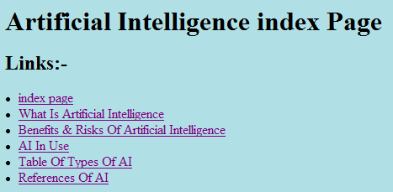

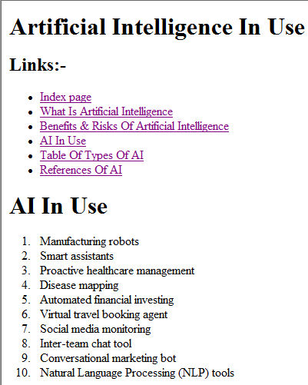

# 

# 

# Source code.



 